**Dumpy Level:**

A **dumpy level** is an instrument used to measure, transfer or set horizontal lines. It is an instrument that is often used in surveying buildings. A dumpy level is used to establish relative height, distance and bearings from different parts of a site. Using this instrument requires a certain amount of skill.

**DUMPY LEVEL**

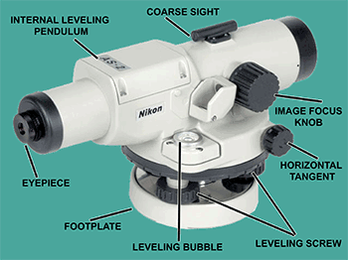

**KEY**

1. Leveling head

2. Telescope

3. Eye-piece

4. Diaphragm

5. Focusing screw

6. Ray-shade

**MAJOR COMPONENTS OF A DUMPY LEVEL**

**TELESCOPE:**

It contains two metal tubes, one of which slides within the other one-tube carries the object glass and the second one carries eyepiece and diaphragm.

**FOCUSSING** **SCREW:**

The telescope is focused by turning the focusing screw either forward or backward.

**BUBBLE TUBES:**

The telescope is attached with two bubble tubes. One is longitudinal and the other is cross bubble tube. These two are placed at right angles to each other.

**DIAPHRAGM:** It carries cross hairs.

**TRIBRACH & TRIVET:**

The telescope with vertical spindle is supported by two parallel triangular Plates. The upper plate is called tribrach and the lower plate is called trivet.

**FOOT SCREWS:**

By turning the foot screws, the tribrach can be raised or lowered to bring the bubble to the center of its run.

**Uses of Dumpy Level**

* Determining the height of a particular point.
* Determining differences in height between points.
* Drawing contours on a land.
* Providing data to calculate volumes for earthworks.
* Setting out level surfaces for construction.
* Setting out inclined surfaces for construction.

**Setting up the dumpy level**

* Choose a position for the dumpy with a good sightline to the datum and also to as much of the ground to be surveyed as possible. Further up the slope is more useful than too low down on the slope. Use the full height of the staff where possible.
* Set up the tripod – it has adjustable feet to allow it to be upright on uneven ground. Ensure the tripod is secure, its feet pressed into the ground if possible. Do not disturb the tripod until it is time to move it again.
* Attach the dumpy to the tripod.
* Level the dumpy using the spirit level – the bubble must be centered in its circle. Turn 2 of the adjustable screws towards or away from each other until the bubble is near the centre. Turn the dumpy 90° towards the untouched screw and adjust this till the bubble is centered.

**THEODOLITE**

The theodolite is an instrument designed for the measurement of horizontal and vertical angles. Theodolite is the most precise instrument; it is also used for laying off horizontal angles, locating points on the line, prolonging the survey lines, establishing grades, determination of difference of elevation setting out curves, observation of bearings etc.

**Types of theodolite:**

The theodolites may be primarily of two types:

* Transit Theodolite
* Non Transit Theodolite

In a transit theodolite the telescope can be revolved through a complete revolution about its horizontal axis in a vertical plane.

In non transit theodolite, the telescope is mounted in such a manner that the line of sight cannot be reversed by revolving the telescope.

**COMPONENTS PARTS OF A THEODOLITE:**

**Leveling head:** It supports the main working parts of the instrument and screw on the tripod. The head comprises of two parts:

* Leveling base or tribrach fitted with leveling foot screws for leveling the instrument.
* Movable head or centering arrangement for centering the vertical axis accurately over the station.

**Lower circular horizontal metal plate:** It carries a circular graduated arc. It is silvered and graduated from 00 to 3600 in a clock wise direction.

**Upper circular horizontal metal plate:** The upper plate carries an index and vernier to Read fine reading on the graduated horizontal circle.

**Telescope:** Fitted to a horizontal axis, it consists of eye piece and diaphragm at one end and objective glass at the other end. The telescope has focusing screw by which any Object can be bisected.

**Circular graduated arc on a vertical circle:** It is attached to the horizontal axis of the telescope. It is usually divided into 4 quadrants, but in some instruments it is graduated from 00 to 3600 the sub divisions of the vertical circle are similar to those of horizontal circle.

**Vernier frame:** carrying an index and verniers to measure vertical angles.

**Lower clamp and lower tangent screw:** A lower clamp, clamps the lower plate and the lower tangent screw enables finely controlled circular motion of lower plate.

**Upper clamp and upper tangent screw:** An upper clamp, clamps the upper plate to lower one, and the upper tangent screw enables finely controlled circular motion about vertical axis.

**Vertical circle clamp and tangent screw:** A vertical circle clamp, clamps the vertical circle and its tangent screw enables a finely controlled circular movement to be given to the combined telescope and vertical circle about the horizontal axis.

**Circular level:** It is located on the top of tribrach.

**Plate level:** It consist of plate bubble, which keeps the instrument parallel to horizontal axis.

**Compass:** A circular or trough compass may be mounted on the vernier plate between the standards for observing bearings.

**Tripod:** Theodolite is mounted and fixed on the tripod for each set up. As tripod has adjustable legs, theodolite can roughly leveled with the adjusting the legs of tripod.

**PLANIMETER**

A Planimeter is used by engineers for measuring area of any figure which has been plotted to scale particularly when the boundaries are irregular or curved. Planimeter is largely used for finding the area of contours in determining the capacity of storage reservoirs.

**DEFINITION OF HORIZONTAL AND VERTICAL ANGLES:**

Horizontal angles are used to determine bearings and directions in control surveys, for locating detail when mapping and for setting out all types of structure. Horizontal angle is the difference between two intersecting lines when they are projected onto the datum plane.

Vertical angles are used when determining the heights of points and to calculate slope corrections. Vertical angle is the angle of elevation or depression between the line of collimation and the horizontal plane which passes through the horizontal axis of the theodolite.

To measure horizontal and vertical angles, a theodolite or a total station is used.

Theodolites are precision instruments used for measuring both vertical and horizontal angles. Two examples of theodolites are: electronic theodolites (which read and display angles automatically) and Optical theodolites (which read and display angles manually).

**Errors in angular measurement**

1. Instrumental errors
2. Human errors
3. Natural errors

**Instrumental Errors:**

* Also called systematic errors, can be corrected through permanent adjustment of the theodolite.
* 5 types: Vertical axis error; Horizontal axis error; Horizontal collimation error; Vertical collimation error; Optical plummet error.

**Natural Errors:**

* Smaller in magnitude and in a random pattern.
* They are:

1. Unequal atmospheric refraction (choose cool days or night time);

2. Differential expansion in certain of the theodolite (insulation);

3. Vibration of the theodolite due to strong wind

4. Improper settlement of the tripod (pushing tripod legs firmly into the grounds)

5. Limitations of the theodolite reading systems and human eyesight

6. Heat shimmer

(Note: minimize time spent on the observations and movements around the theodolite).

**Human Errors:**

* These are mistakes caused by poor observational techniques or carelessness.
* They are serious and significant as it is impossible to correct or make adjustments.
* They can be avoided if proper field procedure is adopted such as observing more than one round of observations.

These errors include:

1. Setting up the theodolite on a wrong station.
2. Sighting a wrong target.
3. Failing to recognize the settlement of the tripod.
4. Transcribing errors and interchanging digit in booking.
5. Reading the wrong circle in the reading system.
6. Ignoring the movement of the plate bubble during observation.
7. Failing to adjust the eyepiece to eliminate parallax completely.

**Sources of Errors:**

**1. Errors in the equipment: Plate level not in adjustment**

The purpose of levelling a theodolite or total station is to make its vertical axis coincide with the vertical through the instrument. If the plate level is not in adjustment, it is possible that when the instrument appears to be level and the plate level bubble centered, the vertical axis may be tilted.

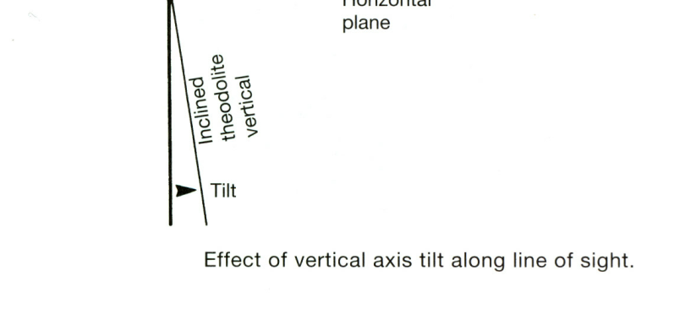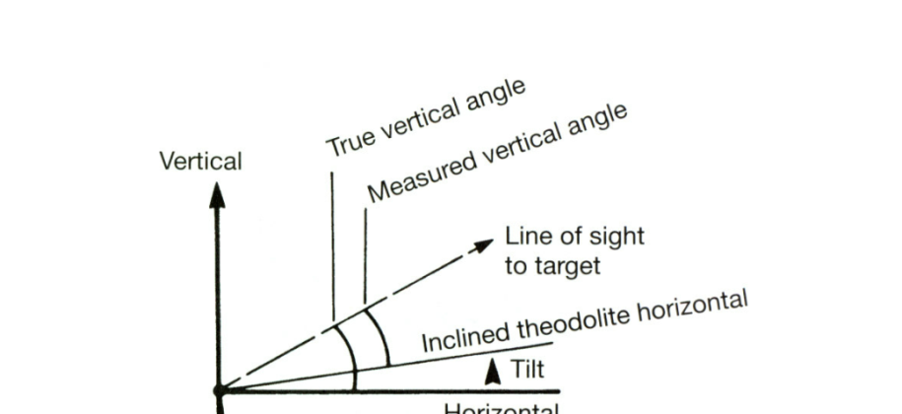

If the instrument is not level, it is not possible to remove any errors caused by this when observing and setting angles on both faces. If the theodolite is levelled electronically, it will usually be fitted with a dual-axis compensator and it can calculate corrections for any errors caused by vertical axis tilt and will apply these to displayed horizontal and vertical angles.

However, the compensator itself may be out of adjustment. To correct for this, an on-board electronic calibration can be carried out in which the compensator index errors are measured and then automatically applied to all readings. It can be shown that the error in horizontal angles caused by the theodolite not being level is proportional to the tangent of the vertical angle of the line of sight.

Consequently, it is important to ensure that the theodolite is carefully levelled for any steep sightings such as those taken to tall buildings and into deep excavations when on site.

**2. Errors in the equipment: Horizontal collimation error**

This error occurs when the line of sight is not perpendicular to the tilting axis - this detected by taking face left and face right horizontal circle readings to the same point – if these do not differ by exactly 180˚, the theodolite has a horizontal collimation error.

The error is removed by taking the average of face left and face right readings to any given point and by taking the mid-point when setting out angles on both faces. It can also be removed in an electronic calibration.

**3. Errors in the equipment: Tilting Axis not horizontal**

If the tilting axis of the theodolite is not perpendicular to the vertical axis, it will not be horizontal when the theodolite has been levelled. Since the telescope rotates about the tilting axis it will not move in a vertical plane which will give rise to errors in measured horizontal angles.

As with the horizontal collimation error, this error is also removed by taking the average of face left and face right readings, by setting out on two faces or by carrying out an electronic calibration on the instrument.

**4. Errors in the equipment: Vertical Collimation error**

When a theodolite is levelled, it is assumed that the automatic vertical circle index sets the vertical circle to read 90˚ when horizontal on face left and 270˚ when horizontal on face right. To detect this error, the same point is sighted on face left and face right and a vertical circle reading taken – when added these should be exactly 360˚ or a vertical collimation error is present in the theodolite.

The vertical collimation error is cancelled by taking the mean of face left and face right readings. To remove this error, an electronic calibration can be carried out.

**5. Errors in the equipment: Plummet error**

The line of collimation of an optical or laser plummet must coincide with the vertical axis of the theodolite. Tests should be carried out on site to check this.

**6. Errors in the equipment: Tripods and Tribach**

The clamping mechanism and circular bubbles of tribrachs should be checked regularly. All of the parts of a tripod should also be inspected regularly to check that they have not become loose.

**7. Field or on site errors: Instrument not levelled properly**

Failure to level a theodolite properly will cause the vertical axis to be tilted

If the instrument has been poorly levelled, errors will occur in measured angles that are not eliminated by observing on face left and face right. Although instruments fitted with dual-axis compensators can correct for the effects of a tilted vertical axis, it is still good practice to take some care when levelling theodolite that have a compensator. If a theodolite is found to be off level whilst measuring or setting out an angle, it is best to re-level the instrument and repeat the measurements.

**8. Field or on site errors: Mis-centering**

If a theodolite is not centered exactly over a point incorrect horizontal angles will be measured. This error increases as the line of sight gets shorter, consequently, great care must be taken with centering when sighting over the short distances that are often used on site and in engineering surveying.

The same errors can occur if a tripod mounted target is not centered properly and when a detail pole is either mis-centered or is not held vertical.

**9. Field or on site errors: not using theodolite properly**

* Make sure parallax is removed
* Change the focus for each target sighted
* Use the tangent (slow motion) screws to intersect targets
* Don’t lean on the tripod

**10. Field or on site errors: ground and weather conditions**

* Avoid setting the instrument up on soft ground
* When working in hot sunshine shade the instrument
* Do not take measurements when refraction is a problem
* Let the instrument adjust to atmospheric conditions

Observing and setting out angles in windy conditions is not recommended

What is compass survey?

Compass survey is a method of surveying by taking bearings and linear distances to produce plan. Bearing is measured using prismatic compass, while the linear distance is measured using measuring tape.

Compass surveying is recommended for use to survey a large area to include:

* The course of a river (or) coast line.
* An area crowded with many details and triangulation is not possible

**Definition of a few compass terms:**

1. MERIDIAN – it is the fixed direction in which the bearings of survey lines are expressed
2. BEARING – it is horizontal angle between the reference meridian and the survey line measured in clockwise or anticlockwise direction
3. TRUE MERIDIAN – The true meridian passing through a point on the earth surface is the line in which a plane passing through and the north and south poles, intersects the surface of the earth.
4. TRUE BEARING – The horizontal angle measured clockwise between the true meridian and the line is called true bearing of the line.
5. MAGNETIC MERIDIAN – the direction indicated by a freely suspended and balanced magnetic needle unaffected by local attractive forces
6. MAGNETIC BEARING – The horizontal angle which a line makes with the magnetic meridian.

**SOURCES OF ERROR IN COMPASS WORK**

* Instrumental errors
* Observational or personal errors
* Errors due to External Influences (natural causes)

**Instrumental Errors:**

They are those which rise due to the faulty adjustments of the instruments. They may be due to the following reasons:

• The needle not being perfectly straight.

• Pivot being bent

• Sluggish needle

• Blunt pivot point

• Improper balancing weight

• Plane of sight not being vertical

• Line of sight not passing through the center of graduated ring

**Observational or Personal Errors:**

They may be due to the following reasons:

•Inaccurate leveling of the compass box.

• Inaccurate centering.

• Inaccurate bisection of signals.

• Carelessness in reading and recording.

**Natural Errors:**

They may be due to following reasons:

• Variation in declination

• Local attraction due to proximity of local attraction forces.

• Magnetic changes in the atmosphere due to clouds and storms.

• Irregular variations due to magnetic storms etc.

**TYPES OF COMPASS:**

There are two types of compass, namely:

1. Prismatic Compass (0 to 360 Degrees)

2. Surveyor’s Compass (0 to 90 Degrees)

The working of a Prismatic compass involves the following three steps: centering, leveling and observation of bearing.

**Fore Bearing and Back Bearing:** The bearing of the line in the direction of progress of the survey is called Fore-Bearing (FB), while the bearing in the opposite direction is called Back Bearing (BB). Therefore BB of a line differs from FB by exactly 180o.

**Designations of bearings**

Bearings are expressed in the following ways;

* **Whole circle bearing:** In this system, the bearing of a line is measured with the magnetic north in clockwise direction. The value of bearing thus varies from 0o to 360o.
* **Quadrant bearing:** In this system, the bearing of a line is measured eastward or westward from north or south whichever is near. The directions can be either clock wise or anti clockwise depending upon the position of the line. It will have value up to 90o.

**DIFFERENCE BETWEEN THE PRISMATIC COMPASS AND THE SURVEYOR'S COMPASS.**

1. Prismatic Compass
   1. The sighting of an object and reading of the bearing are done simultaneously
   2. This can be used without stand
   3. The graduated ring is attached to the magnetic needle
   4. Graduation are marked 0o and 360o in clockwise direction
   5. 0o is marked at south, 180o at north, 90o at west and 270o is marked at east.
   6. It measures or gives the whole circle bearing of a line.
2. Surveyor’s Compass
   1. An object is sighted first and the bearing is then read by going vertically over the middle point
   2. This cannot be used without a stand
   3. The graduated ring and needle are free to move with respect to each other
   4. Graduation are marked 0o to 90o in each quadrant
   5. In this compass, east and west are interchanged
   6. It measures or gives the quadrant bearing of a line

**DESCRIPTION OF THE PARTS OF A COMPASS**

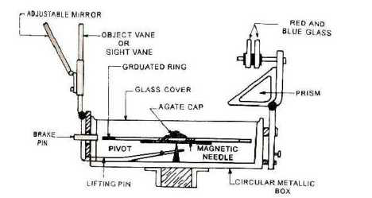

1. Compass Box 2. Magnetic Needle

3. Graduated Ring 4. Pivot

5. Objective Vane 6. Eye Vane

7. Adjustable Mirror 8. Spring Brake

9. Brake Pin 10. Lifting Lever

11. Lifting Pin 12. Prism

13. Focusing Stud 14. Glass Cover

15. Prism Dust Cap 16. Sun Glasses

**COMPASS BOX:**

It is a circular box of diameter 85 to 110 mm having pivot at the center and covered with plain glass at top.

**MAGNETIC NEEDLE:**

It facilitates in taking the bearings of survey lines with reference to the magnetic north.

**GRADUATED RING:**

The bearings are marked inverted on the graduated Rings from 0° to 360° in a clock-wise starting 0° from south.

**PIVOT:**

Magnet is freely held with this.

**OBJECT VANE:**

It consists of prism with a sighting slit at the top. The prism magnifies and erects the inverted graduations.

**BRAKE PIN:**

It is pressed to stop the oscillations of the graduated ring.

**LIFTING PIN:**

On pressing it brings the lifting lever into action.

**COLOUR GLASSES:**

Red and blue glasses are provided with the prism to sight luminous objects

**INTRODUCTION TO PLANE TABLE:**

Plane table surveying is a graphical method of surveying in which field work and plotting are done simultaneously in the field.

The plain table consists of the following:

1. Drawing board mounted on a tripod

2. Straight edge called an alidade.

**The Drawing Board:**

The board is made of well-seasoned wood and varies in size from 40cm x 30 cm to 75cm x 60cm or 50 – 60 cm square.

**The Alidade:**

The alidade consists of metal or box wood straight edge or ruler about 50cm long. The welled edge of the alidade is called the fiducially edge.

**Accessories to the plane table**

1. Trough compass

2. U – frame or plumbing fork

3. Water proof cover.

4. Spirit level or level tube

5. Drawing sheet

6. Pencil or eraser

**Trough compass:** The compass is used to mark the direction of the meridian on the paper.

**U-frame or Plumbing fork:** U frame with a plumb bob used for centering the table.

**Water Proof Cover:** Water Proof cover protects the sheet from rain.

**Spirit level or level tube:** A level tube is used to level the plane table.

**Drawing sheet:** The drawing sheet is fixed on the top of the drawing board.

**Pencil and eraser:** A pencil is used for constructing lines and eraser is used for erasing lines after completion of the plan.

**SETTING UP THE PLANE TABLE**

The setting up the plane table includes the following three operations.

1. Centering the plane table

2. Leveling the plane table

3. Orientation of plane table

**CENTERING THE PLANE TABLE:**

The table should be set up at a convenient height for working say about 1m. The legs of tripod should be spread well apart and firmly fixed in to the ground. The table should be approximately leveled by tripod legs and judging by the eye.

Then the operation of centering is carried out by means of U-frame and plumb bob. The plane table is exactly placed over the ground station by U-frame and plumb bob.

**LEVELING THE PLANE TABLE:**

The process of leveling is carried out with the help of level tube. The bubble of level tube is brought to center in two directions, which are right angles to each other. This is achieved by moving legs.

**ORIENTATION OF PLANE TABLE:**

The process of keeping the plane table always parallel to the position, which is occupied at the first station, is known as orientation. When the plane table is oriented, the lines on the board are parallel to the lines on the ground.